Matthew Haight

Kevin Miller

CPMT483

Login Information & Testing

2012-12-17

Test Accounts

|  |  |  |
| --- | --- | --- |
| **Login Type** | **Username** | **Password** |
| cPanel Gateway | testuser | password |
| Guest | N/A | N/A |
| Customer | testcust@test.com | password |
| Application Administrator | testadmin@test.com | password |
| Restaurant Owner | testowner@test.com | password |

cPanel Gateway Login

The screen in Figure 1 is the cPanel gateway login.

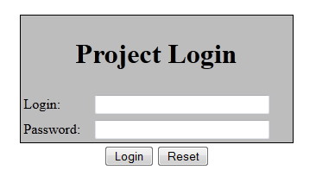

Figure 1

This screen is not part of the Restaurant application, but all users of applications on blue.cs.montclair.edu must be authenticated. There are two levels of access – standard user, and administrator. The test user loging/password is “testuser” and “password”.

cPanel gateway administrators fill see the screen in Figure 2, which allows them to create and modify cPanel gateway accounts.

The cPanel administrators can also view the development log, located at <http://blue.cs.montclair.edu/~cmpt483a/dev/~DevLog.txt> . This log keeps track of the changes made in the development environment, and when the development environment was copied into the production environment. There is also a known issues log that keeps track of bugs and fixes, unimplemented features, etc. This can be viewed at <http://blue.cs.montclair.edu/~cmpt483a/dev/~KnownIssues.txt> .

Pressing the Homepage button takes the admin user to the application homepage. Standard users will bypass the cPanel gateway administration screen and go directly to the application homepage.

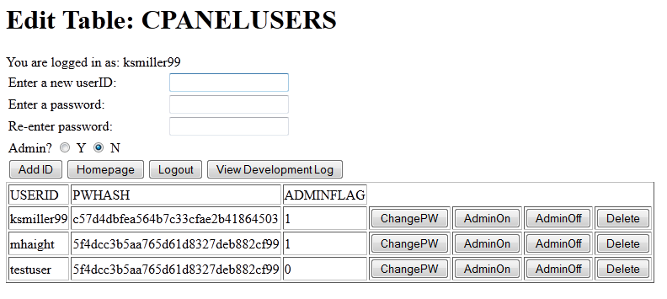

Figure 2

Application Homepage

Figure 3 shows the top portion of the application homepage upon entering the website. Upon entering as Guest, users can browse the menu and begin creating an order. At any point, a registered user can login, or a guest can create a customer account.

Logging in with an account that has administrator privileges will reveal the administrator menu, where operations such as adding/editing/hiding menu items, coupons, and merchandise.

Logging in with an account that has owner privileges will reveal the owner menu, as well as administrator menu. Owners have access to view customer orders.

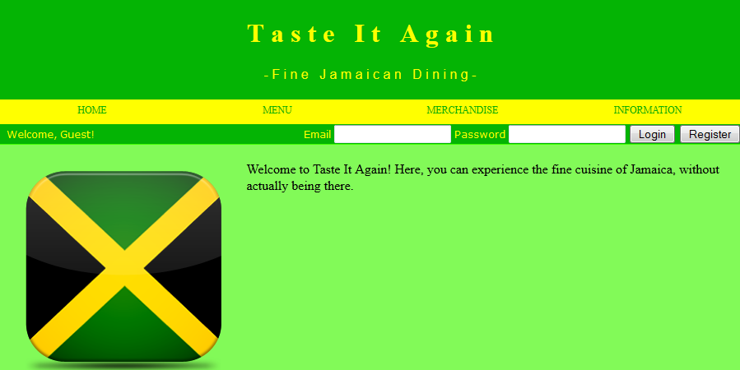

Figure 3